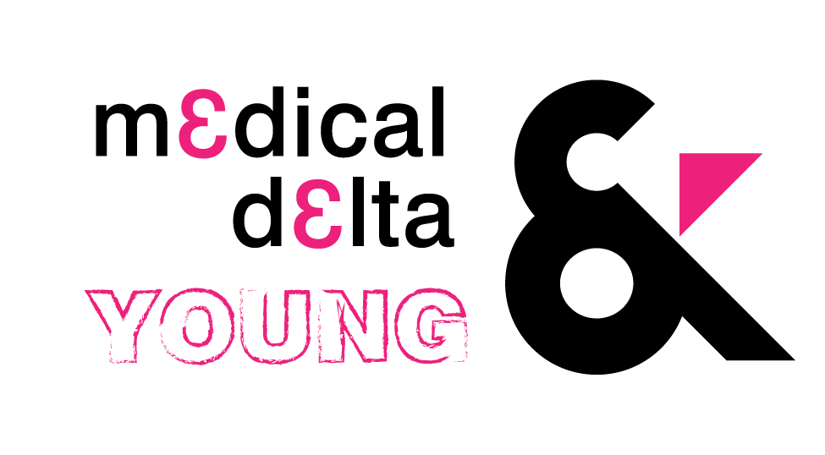

**Application form Thesis Awards**

**Thesis summary**

|  |
| --- |
|  |

**Impact & viability**

*Tell us how you think your thesis will have impact in modern healthcare (taking into account importance, size and scalability). What could be the impact for daily life practice?*

|  |
| --- |
|  |

**Innovation**

*Tell us how the presented thesis is innovative in the field of medical technology.*

|  |
| --- |
|  |

**Human centered design**

*What is the target group of the research in your thesis? Are needs of patients and caregivers incorporated in your thesis?*

|  |
| --- |
|  |

***Contact details:***

Name(s):

Thesis subject:

Institute:

Contact phone number:

Contact email:

PhD / WO master / HBO bachelor:

***Deadline 2 February 2020. Send this application to*** [young@medicaldelta.nl](mailto:young@medicaldelta.nl)

***Save the date: 13th March 2020. One month (13th February) prior we will notify whether or not you have been selected for the final round.***